Chip back potential is the level which bulk silicon is maintained by on-chip connection, or it is the level to which the chip back must be connected when specifically stated below. If no potential is given the chip back should be isolated.

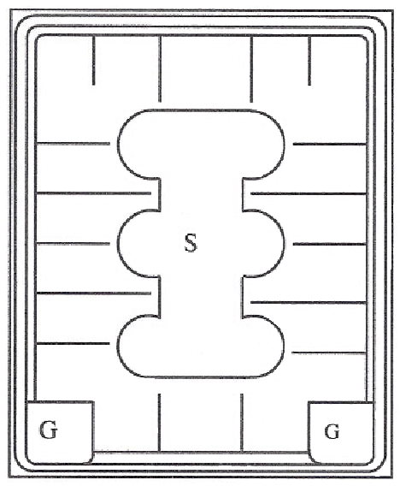

Top Material: Al
Backside Material: TiNiAg
Bond Pad Size: G=43x43, S=197x126
Backside Potential: Drain
Mask Ref:

APPROVED BY: DK DIE SIZE .283” X .348” DATE: 7/21/21
MFG: IXYS THICKNESS .016” P/N: IXTD14N80
DG 10.1.2

Rev B, 7/19/02

